CLIENT ADVICE NOTE

Project: Blackbird Leys Community Centre
Ref: 4023_019
Date: 6TH December 2024

RESERVED MATTERS REPORT 24/02510/RES

Application for the provision of a community centre and public open space surrounding the community centre and block A. Blackbird Leys Community Centre Blackbird Leys Road Oxford Oxfordshire OX4 6HW

Contents:

Summary of Response

- Relevant Site History
- Relevant Policies
- Previous Permission
- Reserved Matters application
- Conclusion

Summary of response.

The application seeks to secure the appearance, landscaping, layout and scale of the new community centre and public realm space as set out in condition 65 of planning permission 23/004005/OUTFUL through a reserved matters submission. The form and scale of the building are to be commended and there is clear evidence of the iterative process taken to reach the submission version. The styling and material palette of the building is sufficiently eye catching to rightly be defined as a key landmark building and sits comfortably alongside the tall building of block A and whilst subservient to it, is not lost in its setting.

The public open space is imaginatively set out, with opportunities for a wide variety of uses. It provides a natural outdoor extension of the community centre in providing an inclusive outdoor space for local residents and visitors, as well as creating a focal “village green” setting for the surrounding buildings.

Taken together, the community centre and the public open space work well overall in transforming this space into a versatile, multipurpose indoor and outdoor hub. There are small adjustments which could be made to the overall layout of both spaces to improve the flow from one to the other and ensuring the outdoor spaces can be used for community events and markets which can then move seamlessly between the indoor and outdoor setting. These are set out in more detail below.

The proposed internal layout presents a number of concerns which again could be remedied by relatively minor modifications to the building which are detailed in the report.

There are a small number of other matters relating to the use and occupancy of the building which the Parish Council may wish to also consider bringing to the attention of OCC.

1. Relevant Site History
1.1 Permission was granted in 2023 for:
23/004005/OUTFUL Hybrid application for the redevelopment of Blackbird Leys District Centre and land off Knights Road, Oxford. Full planning permission is sought for the erection of up to 210 apartments and up to 1,300sqm of retail and commercial space (Use Classes E and Sui Generis) across four buildings on Blackbird Leys Road and the erection of up to 84 dwellinghouses at Knights Road, all with associated demolition of existing buildings and the provision of vehicular accesses, highway improvements, public open space and associated necessary infrastructure. Outline planning permission is sought for the provision of a community centre and public open space surrounding the community centre (Use Classes F2 and E) and block A (community square and green) in the District Centre with all matters reserved except for the principle means of access.
This permission notice was subject to a number of conditions with 62 - 73 relating to the outline permission for the community centre and public open space. Of particular relevance to this application are conditions 67 and 68 as follows:
67 Reserved Matters – Content
All applications for the approval of the reserved matters shall include the following details, unless otherwise agreed in writing by the Local Planning Authority:
a) proposed footways, footpaths, verges, street lighting, cycleways and how these have been positioned to create a walkable and bikeable community;
b) An energy and sustainability statement that specifies the sustainability measures and energy efficient measures that will be incorporated. The report shall also set out (i) how solar aspect, shade and shelter has been considered in the positioning of any buildings; (ii) the consideration of incorporating renewable technologies (such as heat pumps and PV panels) to reduce the consumption of grid electricity; (iii) the sustainability credentials of the buildings to meet policy requirements (iv) how buildings respond to inclusive design and design for health and wellbeing;
c) car parking management plan;
d) a supplementary travel plan;
e) cycle parking in compliance with the relevant adopted standards at that time;
f) street furniture, boundary treatments, signage, refuse storage;
g) accessibility and inclusive design measures
h) architectural detailing, external materials palette and plan demonstrating compliance with the design principles contained within the approved Design and Access Statement
i) landscape plans including planting plans;
j) health impact statement;
k) a waste strategy for waste management and disposal, and material re-use to eliminate avoidable waste; and
l) any additional traffic modelling.
Reason: To ensure a sustainable form of development and a satisfactory quality and appearance and to ensure the local planning authority has sufficient information to assess and determine reserved matters applications in accordance with the Oxford Local Plan 2036 and the policies and standards adopted at the time.
68 Minimum Floor Area
A minimum of 1,200 square metres GIA of community floor space comprising Use Class F2 and/ or sui generis community uses as defined within the Town and Country Planning (Use Classes) (England) Order 1987 (as amended) (or any order revoking and re-enacting that Order with or without modification), shall be provided prior to occupation of the development and used for no other purpose.
Reason: To ensure that the existing community uses are re-provided in accordance with polices SP4, G5 and V7.
2. Relevant Policies

The following National Planning Policy Framework (NPPF) revised 2023 policies are considered to be of greatest relevance in the assessment of this proposal: §131, 135 - 141 (design), §108, 114 - 117 (Transport) - §96 Healthy, Safe Inclusive Places, §96 and §97 Community facilities.

Development Plan

The Oxford Local Plan 2016-2036 (adopted June 2020).
RE1 – Sustainable design and construction
RE5 – Health, wellbeing and Health Impact Assessments
RE6 – Air Quality
RE7 – Managing the impact of development
RE8 – Noise and vibration
RE9 – Land quality
G5 – Existing open space, indoor and outdoor sports and recreation facilities
G8 – New and enhanced Green and Blue Infrastructure Network Features
DH1 - High quality design and placemaking
DH2 – Views and building heights
DH7 – External servicing features and stores
M1 – Prioritising walking, cycling and public transport
M5 – Bicycle parking
V7 – Infrastructure and cultural and community facilities,
AOC3 – Blackbird Leys Area of Change,
SP4 – Blackbird Leys Central Area,
- Oxford Technical Advice Notes,5 Health Impacts Assessment, 8 Biodiversity, 9 Green Spaces, 12 car and cycle parking, 14 Sustainable Design and Construction
- The Oxford Local Plan 2040 has been withdrawn from examination but Policy R1Net Zero buildings in operation, G9 Resilient Design and Construction, R7 Amenity and Environmental Health Impacts of Development, C3 Protection, alteration and provision of local community facilities, C6 Transport Assessments, Travel Plan and Service and Delivery Plans, and SPS9 Blackbird Leys Central Area, are relevant.
3. Previous Permission

3.1 Blackbird Leys Parish Council submitted an objection to the consented scheme. Where relevant to this current application, this is summarised as follows:

In the first response, concerns about the location and function of the community centre and open space (‘village green’); the re-provision of retail and commercial units; parking provision; biodiversity offsetting; and the bigger picture of change in and around Blackbird Leys over the next 10-15 years.
In the second response, highlighting concerns about parking enforcement and traffic; access arrangement to Blackbird Leys Adventure Playground (BLAP); access to GP services; parking enforcement and traffic. The Parish Council requested that they take responsibility for owning and managing the future community centre.

4. Reserved matters application.

4.1 All of the submitted documentation has been reviewed.

4.2 The reserved matters application should address all matters relating to the appearance,
landscaping, layout and scale of the scheme, as set out in condition 67. These have been considered, in turn, below. These are also viewed through the lens of the objection raised by the Parish Council at the outline stage which has been revisited to ascertain if, in relation to the community centre and open space, these are resolved through the reserved matters. As such, the concerns around the following areas have been considered in this report:
a) the location and function of the community centre and open space (village green)
b) the bigger picture of change in and around Blackbird Leys over the next 10 - 15 years
c) access arrangements to the Blackbird Leys Adventure Playground.
d) access to GP services.

4.3 Appearance - the vision for the community centre is to create a landmark building and central focus to the district centre. The building appears distinctive, with the use of materials and colour palette setting it apart from the built form around it. It is clear that significant effort and resource has been committed to ensure the building reflects the community it is designed to serve and the incorporation of community artwork within both the public realm, exterior and interior of the building provide a level of local personalisation of the scheme. The installation of the Glow Tree, a celebrated piece of local artwork, at the centre of this area, adds to the sense of community ownership and place.

4.4 Landscaping - the public realm open space scheme, as presented, provides an Outer Square and an Inner Square with a creative mixture of verdant soft landscaping, trees and planting, pocket park features, seating, play spaces, event space, mown spaces and informal spaces. The proposal appears to have responded well to community feedback through its evolution. To ensure the space is suitable for community events and markets, it is suggested that the developer confirms that the hard surfacing paths, indicated by arrows on the picture below are of sufficient width to allow for the setting up and hosting of market and community stalls, without impacting pedestrian access. (On average gazebo stalls measure 3m x 3m).
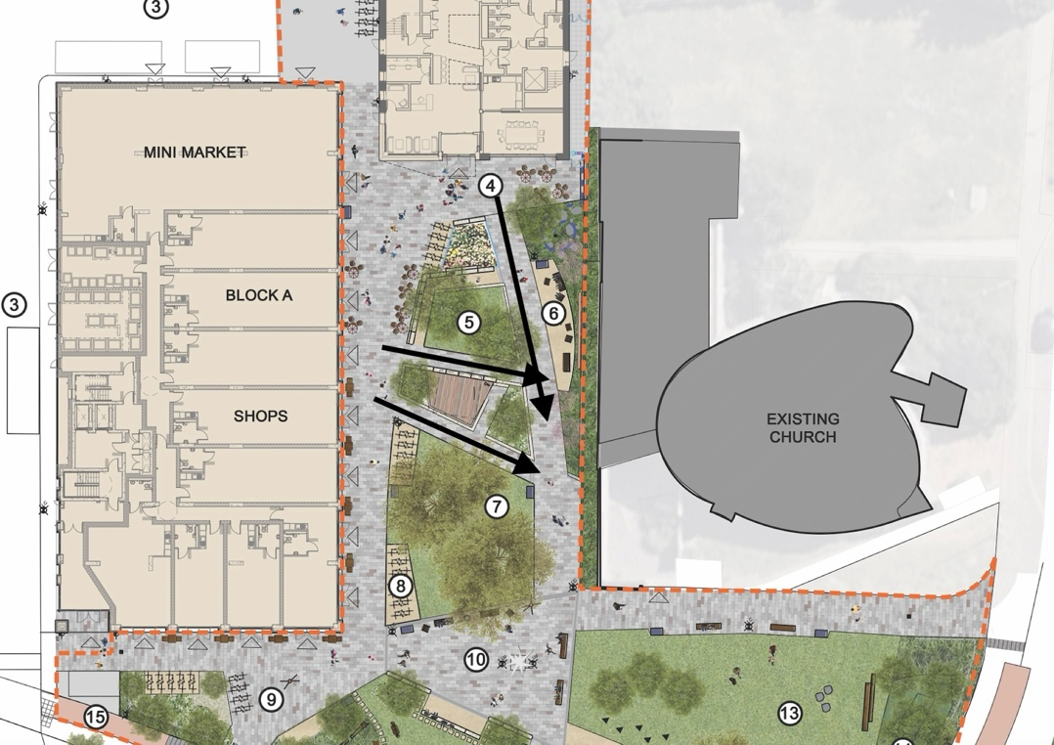

The play strategy is well considered and appears to provide an extensive range of accessible opportunities for a number of different age groups and abilities, for exercise, relaxing, exploring and learning.

4.5 Layout (external). There are a small number of practical considerations which on review of the submitted drawings are noted:
i) There no vehicular access to the side of the community hall for loading and unloading of equipment for events.( there is a single loading bay shared with the retail premises in block A consented as part of the full planning application)
ii) Only three of the accessible parking bays are shown on the enclosed drawings (there are four stated in the application, although the area is outside the curtilage of the current application).
iii) Whilst it is understood that active travel is the priority for the community centre there is concern that the significant reduction in parking provision compared to the previous community centre may impact accessibility.

It is noted that access to the Blackbird Leys Adventure Playground has been considered and incorporated into the external layout of the scheme.

4.6 Layout (internal). - the community centre building needs to be a welcoming, accessible, inclusive space, with an entrance akin to be invited into a front room of a home - relaxed, informal and a place to feel connected to. This needs to be balanced with the practical requirements of the building to deliver usable spaces, able to respond flexibly to changing community needs. In the main this has been achieved and considerable thought has been put into the mix of spaces and uses that likely need to be satisfied, however there are some concerns over the like for like nature of the useable spaces and futureproofing the building to changing community needs over time. (It is noted that whilst the detail of the proposed users occupying the spaces is outside of the scope of the planning application, it would have been useful to understand how they have been accommodated in order to appreciate how the proposals have responded.)
Paragraph 7.10 of the accompanying Planning Statement notes:
“The new community centre has a site area of 564 sqm and useable space of 983 sqm. This is due to the flexibility of the hub and breakout space on each floor providing use for seating, hot desk working and informal socialising in a space that would traditionally be used for circulation. Section 6 of the DAS provides more detail of the internal spaces within the Community Centre and how it has been designed to be welcoming and accessible to all”.
It should be questioned whether all of the breakout spaces are indeed useable space. Of the 38sqm on the second floor, with the void spaces the width of this area is no more than a corridor and provides no real space to sit and chat. With the positioning of the store cupboard doors, tea area and doorways to other rooms, the only space where you could stand or sit without being in the way would be between the internal glazing and the void. There is not really room for hotdesking and seating. A similar situation is presented in the 44sqm breakout space on the first floor, albeit there is room to sit and chat adjacent to Office 2.

The Parish Council indicated concern over longer term change in Blackbird Leys and how this relates to the community centre. The key is flexibility of design and wherever possible internal walls should be partition walls so they can be removed to futureproof the building to changes in usage trends over time or to adapt for other uses such as for the provision of healthcare facilities. As an example, the Stores on the second floor in Office 4, should be moved to Office 3 to enable the partition wall between office 4 and the 1:1 meeting spaces to be removed to create a larger area if needed (as per between Office 3 and Office 4).

Condition 68 states a minimum of 1,200sqm of community centre floor space (GIA). This application appears to satisfy this requirement. The GIA of the Ground Floor is 457sqm, First Floor 419smq, Second Floor 444sqm, which equals 1,320sqm, which is above the requirement. However, as detailed in Planning Statement quoted above, this equates to 983sqm of useable space, less the breakout spaces which are not useable on the second floor and only in part on the first floor, the useable space reduces by around 69sqm to 914sqm.

Therefore, it is for the Parish Council to take a view on whether this is sufficient and is an optimal layout with around 77% of the building being useable space.

Keeping in mind the Parish Council’s previous objection over the function of the community centre, the current layout could be improved to ensure the building has maximised the opportunities to be a truly inclusive and integrated community facility. A number of suggestions are detailed below:

- A community kitchen has been included at 11sqm; the previous centre had a commercial kitchen of 27sqm. The concept is great and allows people to bring their own food in to heat up. However, the space is defined as a domestic style space to heat up food and drink. This does not provide an adequately sized space for community cookery classes or for hirers of the halls wishing to provide more than just tea and coffee at their events. The building should also be available for use as a warm hub for those who need it, which means the kitchen would benefit from being large enough to cater for the preparation, rather than just heating, of hot meals.

- The location of Office 1 on the first floor is impractical, with the large hall above it on the second floor, during office hours, classes in the large hall will create noise from music/voices but also the impact of exercise (encouraged for such uses with the proposed sprung dance floor), which will disturb those occupying the space below. In addition, the types of uses associated with the Main Hall on the second floor are likely to need equipment within those spaces which again is impractical to carry up two flights of stairs or put into a small lift.

- In considering longer term uses, wherever the small hall and office are located, there should be a removable dividing wall between then so the space can be opened up as needed in the future should the demand for office space change.

- The inclusion of an I.T bar on the ground floor is welcomed and providing a space where community users can access the internet as they did in the previous Community Centre, is a valuable inclusion. However, the location of the space in the Hub 1 in a high footfall area where all users of the building will pass by does not make for a peaceful quiet space for this purpose. An alternative location could be considered which may be more conducive.

- The covered entrance could be extended across the full width of the building to provide an undercover seating area for enjoying the public realm space in a sheltered environment in the shade or when raining. Alternatively, this could be included with more temporary awning or similar.

- The covered entrance with balcony above is a really creative way of providing both an undercover feature at the main access point to the building and incorporating outside space at the first-floor level of the building, with the opportunity to enjoy looking out on the public realm space below. Whilst this space will likely be used by staff or office workers in the building could this be a good location for a community kitchen garden programme to improve its occupancy and function.

- Whilst the changing places space and baby changing are welcomed there does not appear to be any showering facility, which given the prioritisation of active travel, would be a welcome addition within the changing spaces location for those working in the centre.

4.7 Scale. This has been well considered and through a number of iterations has resulted in a building which makes a visual statement as a local landmark, without being overly obtrusive or overbearing; subservient to the neighbouring block A without being dominated by it.

Other matters

4.8 The Parish Council has expressed concern that there is no indication of the intended occupiers of these spaces. Whilst not a planning matter, the Council would like reassurance that they and other regular uses of the previous community centre who wish to use the new facility, will be welcomed into this space and accommodated for their regular meetings.

4.9 The use class of the community centre approved at the outline stage was for Classes F2 and E to cover the community uses and office use of the building. There is therefore nothing currently to prevent the building being principally occupied by commercial Class E uses, which is not the intention of the facility. It is therefore recommended that consideration is given as to how to ensure that only Class E uses which are commensurate to a community centre setting, be permitted or that the defined use of the building is clarified. The Parish Council may wish to review the Class E uses as set out in the Use Classes Order 2020, but as a guide, it is suggested that only the following Class E uses should be permitted to allow for the current and potential future uses of the building as a community centre.

(d)for indoor sport, recreation or fitness, not involving motorised vehicles or firearms, principally to visiting members of the public,
(e)for the provision of medical or health services, principally to visiting members of the public, except the use of premises attached to the residence of the consultant or practitioner,

(f)for a creche, day nursery or day centre, not including a residential use, principally to visiting members of the public,

(g)for— (i)an office to carry out any operational or administrative functions,

5. Conclusion

5.1 The documentation required to comply with the requirements of conditions 67 and 68 as set out in the previous permission 23/004005/OUTFUL have all been provided.

5.2 This report has focused on the main matters pertaining to appearance, landscaping, layout and scale of the scheme and the comments provided arise from a detailed review of the Planning Statement, Design and Access Statement, Play Strategy, Landscaping and Community Engagement Reports and accompanying drawings. This is on the basis that the Parish Council requested a response which focused on ensuring that the needs of the community are to be met through this reserved matter application.

5.3 No specific comments have been raised in relation to the waste strategy, sustainability statement, travel plan, heritage statement, drainage report, energy strategy and whole life carbon cycle.

5.4 The proposals, as presented, appear to demonstrate significant time and resource spent in working with the local community to ensure the community centre and public open space create the intended exemplar facility for the residents of Blackbird Leys which they can take pride in. A few modifications and clarifications have been suggested in the report which it is hoped are taken as intended as constructive comments in order to maximise the functioning of the spaces both now and in the future.

